Consultant Profile 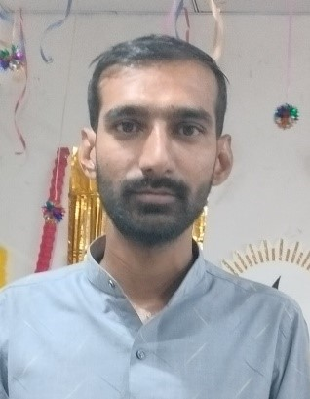
Harshil H Savania
Sr. Frontend Developer

Objective

To take up challenging careers and grow consistently along with the organization.

Professional Summary

- I have approx. 7 years of experience as a Frontend Developer.
- Ability to design the layout of the website.
- Ability to work well in a team, as an individual and as a team leader.

Skills

- HTML, HTML5, CSS, CSS3, SASS, SCSS, Bootstrap, JavaScript, jQuery, Beginner in React Js
- Quality Assurance
- Great ability to lead the team and work with colleagues.
- Quick learner and great ability to teach

Assignments: -
1) Name: Ola Electric - Magento 2 CMS Application
URL: https://www.olaelectric.com/
Responsibility: -
- I have created designs from Figma to HTML, CSS and Responsive. And have worked in scripting languages like JavaScript and jQuery.
- Design created through Magezon Page Builder.

2) Name: Malone Electrical Solutions – Core PHP
URL: https://www.maloneelectricalsolutions.com/
Responsibility: -
- In this Project I have created Design from PSD to Bootstrap with Responsive.
- Also worked on Site Speed up for Website.

3) Name: Obay - Magento 2
URL: https://www.obay.com.au/
Responsibility: -
- In this Project I have created Design from Zeplin to Bootstrap with Responsive.
- Customize header, menu, Homepage, PLP & PDP in theme.
- Created Site Speed Up from Frontend Side for SEO.
4) Name: Tamaken - Magento 2
URL: https://www.tamakan.com/
Responsibility: -
- In this Project I have created Design from PSD to HTML, CSS with Responsive.
- In this Project i have so many challenges in CSS. Because some CSS are coming from Inline Stylesheet and some are from Internal CSS.

5) Name: Hbftextiles - Magento 2

Responsibility: -
- Here I worked from Figma to Html, CSS with Responsive.
- Created Email Template Design.
- Also worked in customization in Scripting languages in jQuery.

6) Name: Mavidon – Core PHP
URL: https://web4jewelers.com/
Responsibility: -
- Here I worked from PSD to Html, CSS with Responsive.
- Created Email Template Design
- Created Site Speed Up from Frontend Side for SEO.

7) Name: Addison – Core PHP
URL: http://www.ithappensinaddison.com/
Responsibility: -
- Here I worked from PSD to Html, CSS with Responsive.

- Created Email Template Design

8) Name: Vanhorlicks – Magento
URL: http://www.ithappensinaddison.com/
Responsibility: -
- I worked from PSD to Bootstrap for design.
- In here i was Challenges in the date picker design.

9) Name: Eklok – Magento
URL: https://e-klok.se/
Responsibility: -
- I worked from PSD to Html CSS and Responsive for design.
- In here i was Challenges on Site Speed Up for SEO.
- Worked as Also in Customization through jQuery.

10) Name: Rapid Healthcare – WordPress
URL: https://rapid-healthcare.com/
Responsibility: -
- I worked from PSD to WordPress.
- In here i have challenges in banner section for screen wise.
- In here i was Challenges on Site Speed Up for SEO.

11) Name: Web 4 Jewelers – WordPress
URL: https://web4jewelers.com/
Responsibility: -
- I worked from PSD to WordPress.
- Some Challenges on Custome Responsive Design.

Work Experience: -
Employer | Designation | Period of Work
Tarento Tehcnologies Pvt. Ltd | Sr. Frontend Developer | December 2021 - Present
Webile Technologies Pvt. Ltd | Sr. Frontend Developer | May 2020 - November 2021
Aims Infosoft | Sr. Frontend Developer | April 2018 - 2020 March
HR InfoCare Private Limited | Jr. Frontend Developer | September 2016 - March 2018

Educational Qualifications: -

Qualification | Year of passing | Institution | University / Board
BCOM | 2015 | N. M. ZALA | Gujarat University

Language Skills: -

- Gujarati – mother tongue
- Hindi – fluent
- English – fluent

